11-STEM 1 and 2
HOW SOCIETY/IES IS/ARE ORGANIZED?
SOCIALLY  Groups 1 & 2  STEM 2  GROUP 1  Manuel, Cabangahan, Fideles, Marquez, Quialquial , David (hi guys may isa pa ata tayong kagroup sino po ung nawawalang tupa thanks  GROUP 2  Paragoso, Maranao, Salazar, Kishia Mendoza, Mohammed, Rosillosa | CULTURALLY  Group 3  STEM 2  GROUP 3  Aspera, Macaalay, Maranan, Ladra, Pechon | ECONOMICALLY  Group 4  GROUP 4:  Cayabyab, Feliciano, Leaño, Vicente, Arguelles | POLITICALLY  Group( 5 & 6)  GROUP 5:  Badron, Ilagan, Lagasca, Motas, Mayo,  Group 6:  Buna, Enriquez,Hernandez,Vargas,
By kinship (relatedness):  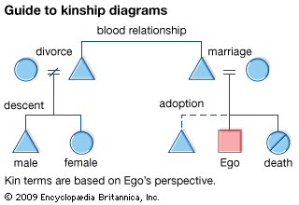  By blood (consanguineal)  - also known as Consanguineal kinship  - considered as the most basic and general form of relations  Ex. relationship between siblings, nieces/nephews, aunts/uncles, parents and their children, etc.    By law (affinal kinship)  - In law, affinity is the kinship relationship created or that exists between two people as a result of someone's marriage.  - In law, affinity may be relevant in relation to prohibitions on incestuous sexual relations.  Ex. In Michigan, sexual contact between persons related by blood is chargeable as criminal sexual conduct.  - Maranao    By Ritual:  1. Compadrazgo - ritualized form of co-parenthood or family.  Ex. Baptism, Confirmation, Marriage  By Marriage:  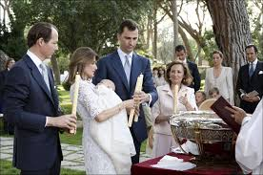  Endogamy - marriage within local community, clan or tribe  Exogamy - required to marry outside their own group, community, or social classes.  Polygamy - the practice of having more than one partner or sexual mate.  > Polygyny - a man has multiple female partners or mates.  > Polyandry - a woman has multiple male partners and mates.  Monogamy - “one union“. Refers to the marriage or sexual partnering custom or practice where an individual has only one partner or mate.  Referred Marriage and Arranged Marriages:  1. Child Marriage  - when parents arrange the marriage of their child long before marriage takes place.  2. Exchange Marriage  - reciprocal exchange of spouses between two countries/race  3. Diplomatic Marriage  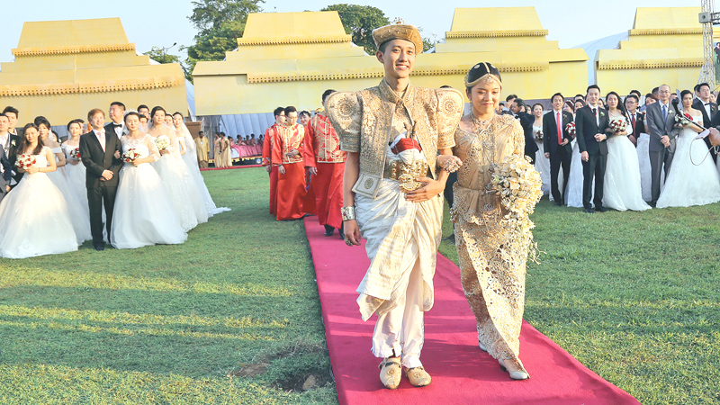  - arranged marriage established between two royal or political families  4. Modern Arranged Marriage  - the child’s parents, with consent of the child, choose from several possible mates.  By Family:  1. Nuclear Family    - type of family group consisting of two parents and their children.  2. Extended Family  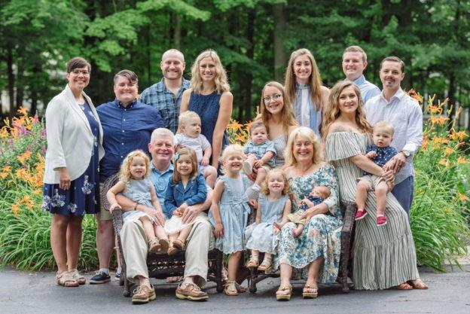  - a family which extends beyond the nuclear family to include grandparents and other relatives.  3. Blended Family  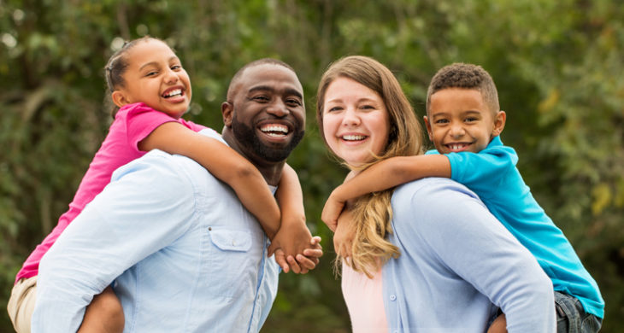  - type of family where the parents have a child/ren from previous marital relationships (Complex Family)  By Preferred  Residence/Household:  - Patrilocal  - occurs when married couples stay in the house of the husband’s relatives or near the husband’s kin  - Matrilocal  - happens when the couples live with the wife’s relatives or near the wife’s kin  - Biolocal  - happens when the newly-wed couple stay with the husband’s relatives and the wife’s kin alternately  - Neolocal  - living or located away from both husband’s and the wife’s relatives.  By Descent and Lineage  Descent - a biological relationship that often refers to an individual’s child or offspring or his/her parents and ancestry  Lineage - direct descent from an ancestor; ancestry or pedigree. The line descendants of a particular ancestor or family  - Unilineal - tracing descent either exclusively in the side of the mother or the father.  - Patrilineal -those that connect generations through the father’s line.  -VINACE SALAZAR.  - Matrilineal -is the tracing of kinship through the female line. -JIBRAEL MOHAMMAD  - Bilateral - a family arrangement where descent and inheritance are passed equally through both parents.  -Kishia Mendoza  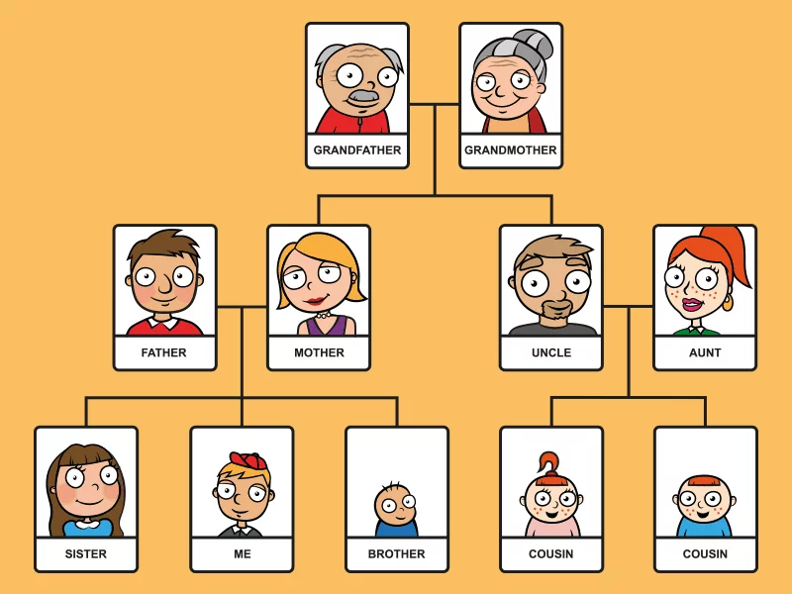 | By the different geographic and cultural regions/groupings:  Ex. Saudi Arabia, Philippines, China, America, Japan, Korea, etc.  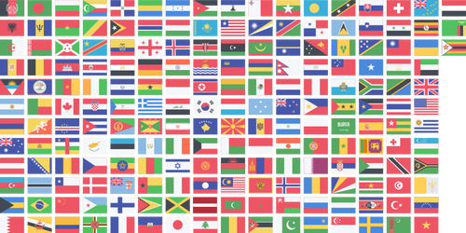  By religious affiliations:  Ex: Christianity, Islam, Hinduism, Buddhism, Judaism, etc.  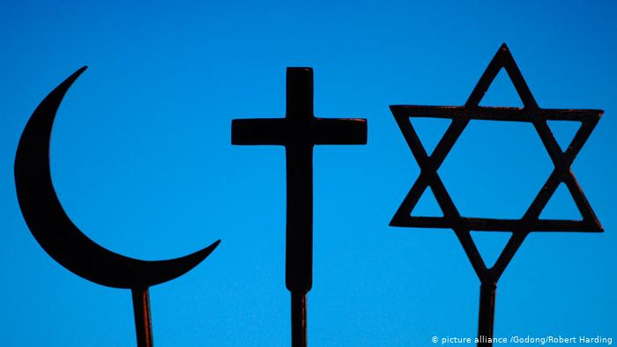  By the facilitation of cultural understandings by ways of communication, education, and improved transportation networks:  Ex. The WWW or worldwide web, social media, advances in cellular technologies, schools (both online and physical)   | By business organizations:  - sole proprietorship-  owned and run by one individual who receives all profits and has unlimited responsibility for all losses.  -no legal distinction between the owner and the business entity.  -owners do not necessarily need to be alone, they can employ other people.    - partnership-  is an arrangement between two or more people to oversee business operations and share its profits and liabilities.  -The partners in a partnership may be individuals, businesses, interest-based organizations, schools, governments or combinations.    - cooperatives -  an autonomous association of persons united voluntarily to meet their common economic, social, and cultural needs aspirations through a jointly-owned enterprise.  - democratically owned by their members, with each member having one vote in electing the board of directors.  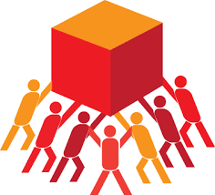  - corporations -  is a business entity that is owned by shareholder(s), who elect a board of directors to oversee the organization’s activities    Meanings:  - National -may refer to the goods and services which a country is able to produce at any given time using all the natural, human and capital resources available to it.  - Transnational - is an extending or operating across national; boundaries;  - it is a multinational company  - Multinational - includes or involves several countries or individuals of several nationalities;  - it is a company operating in several countries.   | By institutions of local/global governing bodies and authorities in any of the following forms:  LOCAL GOVERNMENTS:  - Democracy- governed by the elected representatives.  ex. Philippines, India South Korea  - Aristocracy-a form of government in which power is held by the nobility.  ex. England, Spain Denmark,  - Monarchy- Is a form of government where a king or queen rules the kingdom.  ex. Saudi Arabia, Bahrain, United Kingdom  - Federal-division of power between central government and local state governments.  ex. Argentina, Russia, United States  - Unitary-is a governing system in which a single central government has total power over all of its other political subdivisions  ex. Andorra, Bhutan,  Brunei  REGIONAL AND GLOBAL ASSOCIATIONS:    - European Union  - The Union currently counts 27 EU countries.  - The United Kingdom withdrew from the European Union on 31 January 2020.    - ASEAN  - Regional grouping that promotes economic, political, and security cooperation among its ten members: Brunei, Cambodia, Indonesia, Laos, Malaysia, Myanmar, the Philippines, Singapore, Thailand, and Vietnam.  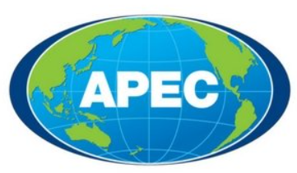  - APEC  - Is an intergovernmental grouping operating on the basis of non-binding commitments, open dialogue and equal respect for the views of all participants.  - It was established in 1989 to further enhance economic growth and prosperity for the region and to strengthen the Asia-Pacific community.  - UN  - The world’s largest diplomatic organization.  - The United Nations is an international organization founded in 1945.  - It is currently made up of 193 Member States.  - The mission and work of the United Nations are guided by the purposes and principles contained in its founding Charter.  Other Examples:  BY AUTHORITY:  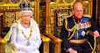  - Traditional - is a form of leadership in which the authority of an organization or a ruling regime is largely tied to tradition or custom  Example: monarchy, tribal leaders  Note: Just because a government follows a traditional pattern doesn’t mean that it’s ineffective. There are a lot of well-developed countries that still rely on a traditional government. (Another important insight is that some countries that follow a traditional government are doing better economically than other countries that follow a different government regime.)  - Charismatic - a type of organization or a type of leadership in which authority derives from the charisma of the leader  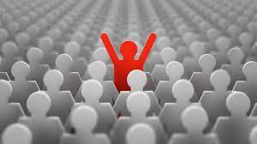  Example:  The very leadership being exhibited by Pres. Duterte  Note: A charismatic leader is one who has the capability to lead beyond or against what is allowed by the existing laws or standards of morality. How and why? All because of the leader’s ‘oozing’ popularity and charisma to the people  (A charismatic leader must also be able to make hard decisions. A leader who just bases his/her actions based on what reaction they will get from the nation is not a good leader.)  - Rational-Legal -is a form of leadership in which the authority of an organization or a ruling regime is largely tied to legal rationality, legal legitimacy and bureaucracy    Example: the very means by which authority is acquired and granted to people and government officials through existing laws like the Philippine Constitution and its many Republic Acts  Note: A Rational-Legal form of government is most prone to unfair victories and illogical outcomes. There have been a lot of cases (particularly in the Philippines) that some candidates did not deserve to win but somehow won because of their looks or their past. Some candidates even won by using empty promises on the people.
The overarching/binding role of culture in the organization of society
Group 7
STEM 2: Fallorina, Santos, Renolayan, Magcalas, Panuela,Braga
- Our culture is our way of life which measures the quality of our life and the health of our society. (Santos)
- Through culture, people and groups define themselves, conform to society’s shared values, and contribute to society. (Fallorina)
- Culture in other ways reflects what’s the history of our society. (Santos)
- Culture or shared experiences, beliefs and values has the power to unify people around a common purpose. (Fallorina)

- Our culture helps us develop a sense of belongingness and ability to relate to each other. (Fallorina)
- Culture sets expectations for how people behave and work together and how well they function within society.( Renolayan)
- Culture is the reflection of a community or a nation.( Renolayan)
- Culture is what defines an entire community and what labels us humans “humans”. (Panuela)
- With culture it is the expression of human creativity. (Panuela)
- Culture set as an example in a society(Magcalas)
- Culture can separate the limits between siloed groups, direct dynamics, and improve the work process generally speaking(Magcalas).
- culture helps shape our identity and form our personality. (Braga)
- Having the same culture with other people gives them a common trait and makes it easier to have interactions with one another. (Braga)

OBSERVED FACTORS CONTRIBUTORY TO THE WORSENING OF PROBLEMS PRESENTED IN THE VIDEO CLIPS AND INNOVATIONS THAT MUST AND MAY BE TAKEN TO HELP IN SOLVING THE FORECASTED PROBLEMS
GRP 1  STEM 1:  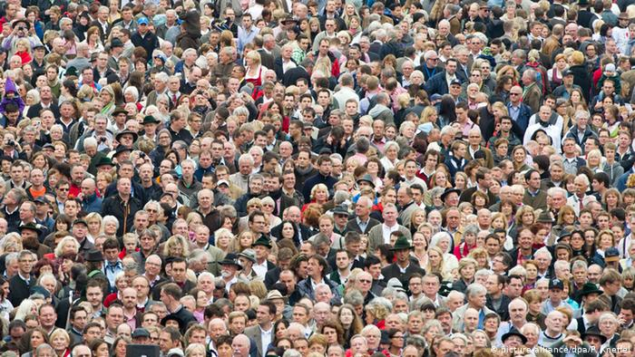  STEM 2  Problem: Overpopulation  Observed Factors:  -Birth rate is greater than the mortality rate.  -The continent which has the fastest growing population, Africa, has limited access to contraceptives.  -Some traditions deem contraceptives as dangerous  Possible Innovations:  - In a lot of countries, the birth control burden is solely on women. Education such as Family Planning should be available for both men and women. Also, education on sexual intercourse and the use of birth control can be available to students as early as 4th Grade.  - invention of effective and accessible male contraceptives  - Overpopulation or overabundance occurs when a species' population becomes so excessive that people deem it must be managed. It can result from an increase in births, a decline in the mortality rate, an increase in immigration, or a depletion of resources.  - Simply educating men and women about contraception can have a big impact. When Iran introduced a national family planning programme in 1989, its fertility rate fell from 5.6 births per woman to 2.6 in a decade. A similar effort in Rwanda saw a threefold increase in contraception usage in just five years. | GRP 2  STEM 1:    STEM 2  Problem:  Education (Maranao)  Observed Factors:  -poverty  -lack of access to quality education  -lack of funding  -living in countries at risk  (paragoso)  Possible Innovations:  -government programs to advance education sector  -more support to educational sector  -providing training for school personnel in order to further advance and improve the quality of education to encourage people to go to school  (paragoso)  -Educational Reforms. It aims to transform school structures with the aim of raising the quality of education in a country. Educational reforms deserve a holistic examination of their reasons, objectives, application and results generated, by those within the school systems where they are implemented. (Rosillosa) | GRP 3  STEM 1:    STEM 2  Problem:  Echo chambers and social media polarization  Observed Factors:  Cancelling others opinions/beliefs  Spread of misinformation  Possible Innovations:  Try to understand someone's point or belief and be open minded, also try to lessen using social media apps too often  Be mature enough to avoid any intentions of spreading false rumors.  Be knowledgeable of what really is going on by doing some actual research instead of jumping to conclusions; be a good netizen.  Be mindful and acknowledge one's opinion all the time. | GRP 4  STEM 1:  STEM 2  Problem:  Overworked Employees  Observed Factors:  Unmanageable workloads resulting in employees getting stressed which often leads to quitting.  Possible Innovations:  - Work should be equally divided among the employee’s and well within their capabilities.  - Work time, break time, projects completion and deadline should all be properly scheduled and followed so that the employees can work comfortably while also getting their work done within time. | GRP 5  STEM 1:    STEM 2  Problem: Unemployment  Observed Factors:  Corruption and immorality (prioritizing property over people)  Possible Innovations:  -Lower the cost of properties and elevate the cost of talents (so that people will value people more), lower the cost of living, employ more people, lower the price for houses or apartments.  -Conduct more free work-related seminars so that the uneducated people will have a better chance at landing jobs  -Create more job opportunities | GRP 6  STEM 1:  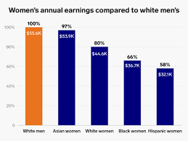  STEM 2  Problem:  Wage Gap  Observed Factors:  Racial and Gender discrimination  Possible Innovations:  - Those who are willing well known personalities (artists, politicians, etc.) should participate in advocating social equality since their influence is big.  -People should fix their mindset and judgement by looking at both genders being the same variables so workers would be treated fairly and nicely.  -Employers should raise the minimum wage regardless of race and gender. Workers (whether a male or a female) must receive a salary which is equal to their workload.  -The problem including its factors could be disclosed by implementing workplace anti-discrimination laws/policies with corresponding fines | GRP 7  STEM 1:  STEM 2:  Fallorina, Santos, Renolayan, Magcalas, Panuela, and Braga  Problem: Unsustainable Ecosystem  Observed Factors:  - People do whatever they want to satisfy their desires without knowing that they are making the environment suffer. (Fallorina)  - Most of the World’s population live in cities which consume most of the world’s energy. (Fallorina)  - People don’t think about the possible outcomes and problems which can result in harming mother nature. They would do everything just to get what they need and they don’t think about the consequences of their doings. (Santos)  - People think that a single trash will not affect the world and they do not consider the fact that others think the same. This causes millions of people to throw trash that piles up quickly.  People always think that this problem will be over and they can solve it right away and they tend to overlook things and they always think that it will be better soon.(magcalas)  Possible Innovations:  - Prioritize projects that concern combating climate change.  - Make safe, resilient and sustainable cities by reducing the amount of energy and resources used through improving the efficiency of transportation, constructing efficient buildings and obtaining energy from natural and clean sources. (Fallorina)  - Make a campaign regarding the bad outcome if ever there is someone who would use unsafe materials that can harm the environment (Santos)  - Make a law that would imprison people who would use unsafe materials that can harm the environment.  (Santos)  - Use of renewables such as solar and wind power can be explored more and utilized to reduce the dependence on fossil fuel, which is a major cause of environmental pollution, climate change, global warming, and destruction of natural habitats.  (RENOLAYAN)  The plastic industry has the opportunity to move away from a “take, make, and dispose” business model and adiot a circular model, which aims to eliminate waste across sectors while creating economic, societal, and environmental benefits. One promising circular process is pyrolysis.  - There should be more trash cans and cigarette disposals in places that are usually crowded to encourage people to dispose of trash properly instead of them thinking that a trash can is too far away to do a simple task.  -They should make a law that with every trash that they don’t properly dispose they should fine accordingly(Magcalas)  -Seminars and class for recycling and proper disposal of garbages (within communities and town) (Magcalas)

